Project Documentation

STORE MANAGER:keep track of inventory.

1. Introduction

• Project Title: Store Manager: keep track of inventory .

TEAM ID: NM2025TMID33787

TEAM LEADER: THAHSEEN BANU.T - [thahseen753@gmail.com](mailto:thahseen753@gmail.com)

TEAM MEMBERS: MALINI.S - [sangeethamalini85@gmail.com](mailto:sangeethamalini85@gmail.com)

AFRA SUHAINA.N – [navas.afra1995@gmail.com](mailto:navas.afra1995@gmail.com)

SUMAIYA.A - [sumiakbar06@gmail.com](mailto:sumiakbar06@gmail.com)

PURPOSE:

The purpose of the Store Manager pro

ject is to make inventory management easier and

more efficient. In many small shops and stores, products are managed manually in

notebooks or registers. This often leads to mistakes like missing items, wrong stock counts,

or difficulty in updating product details.

FEATURES:

Store Manager: Keep Track of Inventory .

Here are some key features and a description of an inventory management system:

Inventory Management: Inventory Management helps maintain healthy stock levels in a

store and acquire them in time.

Stock Updates: Stock will automatically update on sale of products, and it can be updated

on adding new stock.

Cart: Products can be added to cart for a particular sale and quantity can be added to

each product.

Checkout at Cart: Upon checkout, cart is cleared, inventory is updated, and a sale record

is made.

Adding New Products to Inventory: New products can be added to the inventory by

providing product name, image URL, price, stock, tags.

Alert View for Depleting Stock: Depleting stocks are shown in red background, and alert requirements

Search Functionality for Products: Products in inventory and product catalog can be

searched.

Sale Records: All sale records are stored with sale value, products and datetime.

Architecture – Store Manager

The architecture of the Store Manager pro

ject follows a client–server model. It mainly

consists of three layers:

1. Frontend :

Developed using React.js.

Provides the user interface where shopkeepers can add, update, delete, and view products.

Ensures a simple and user-friendly interaction.

2. Backend :

Implemented using Node.js with npm packages.

Handles the logic of the application and runs the project commands.

Acts as a bridge between the frontend and the database.

3. Database:

MongoDB is used for storing product details like Product ID, Name, Price, and

Quantity.Provides permanent storage and easy retrieval of data.

Project setup and configuration

Project Setup

Step 1: Initialize a new React application.

Use create-react-app or Vite for project 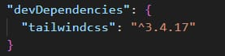

Step 2: Install dependencies.

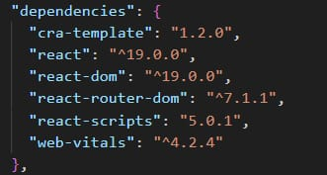Add tailwindcss, react, react-dom, and other necessary Step 3: Configure TailwindCSS.

Set up the tailwind. config.js file.

Add the required styles in index.css.

Step 4: Create a basic folder structure.

Example:

css

src/

??? components/

??? context/

??? hooks/

??? pages/

<https://react.dev/learn/installation>

<https://react-bootstrap-v4.netlify.app/getting-started/introduction/>

<https://axios-http.com/docs/intro>

<https://reactrouter.com/en/main/start/tutorial>

Inventory: Add hover effects and responsive search bar.

Cart: Highlight selected products and display alerts on low stock.

Sales: Use a clean table or card layout for sale records.

Step 3: Ensure consistency.

Apply a theme or consistent color palette.

Milestone 6 - Testing and Debugging

Step 1: Test individual components.

Ensure correct rendering and functionality.

Step 2: Test context and reducers.

Verify state updates and interactions with localStorage.

Step 3: Debug UI/UX issues.

Check for responsiveness and usability.

PRE-REQUISITES

Here are the key prerequisites for developing a frontend application using React.js:

Node.js and npm:

Node.js is a powerful JavaScript runtime environment that allows you to run JavaScript

code on the local environment. It provides a scalable and efficient platform for building

network applications.

Install Node.js and npm on your development machine, as they are required to runJavaScript on the server side.

Download: <https://nodejs.org/en/download/>

Installations: <https://nodejs.org/en/download/package-manager/>

React.js:

React.js is a popular JavaScript library for building user interfaces. It enables developers to create interactive and reusable UI components, making it easier to build dynamic and responsive web applications.

Install React.js, a JavaScript library for building user interfaces.

Create a new React app:

npx create-react-app my-react-app

Replace my-react-app with your preferred project name.

Navigate to the project directory:

cd my-react-app

Running the React App:

With the React app created, you can now start the development server and see your React application in action.

Start the development server:

npm start

This command launches the development server, and you can access your React app at <http://localhost:3000> in your web browser.

HTML, CSS, and JavaScript: Basic knowledge of HTML for creating the structure of your app, CSS for styling, and JavaScript for client-side interactivity is essential.

Version Control: Use Git for version control, enabling collaboration and tracking changes throughout the development process. Platforms like GitHub or Bitbucket can host your repository.

• Git: Download and installation instructions can be found at: <https://git-scm.com/downloads>

Development Environment: Choose a code editor or Integrated Development Environment (IDE) that suits your preferences, such as Visual Studio Code, Sublime Text, or WebStorm.

• Visual Studio Code: Download from <https://code.visualstudio.com/download>

• Sublime Text: Download from <https://www.sublimetext.com/download>

• WebStorm: Download from <https://www.jetbrains.com/webstorm/download>

To get the Application project from drive:

Follow below steps:

Install Dependencies:

• Navigate into the cloned repository directory and install libraries:

cd store

npm install

Start the Development Server:

• To start the development server, execute the following command:

npm start

Access the App:

• Open your web browser and navigate to http://localhost:3000

• You should see the application's homepage, indicating that the installation and setup were successful.

You have successfully installed and set up the application on your local machine. You can now proceed with further customization, development, and testing as needed

Project structure,:

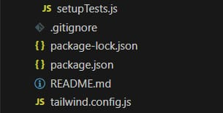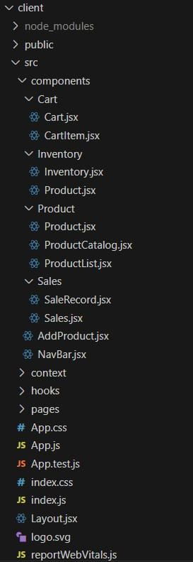The image is of the folder structure which shows all the files and folders that have been used in project

Project implementation and Execution:

Product catalog:

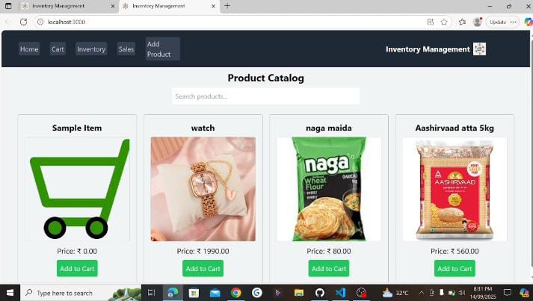

Cart:

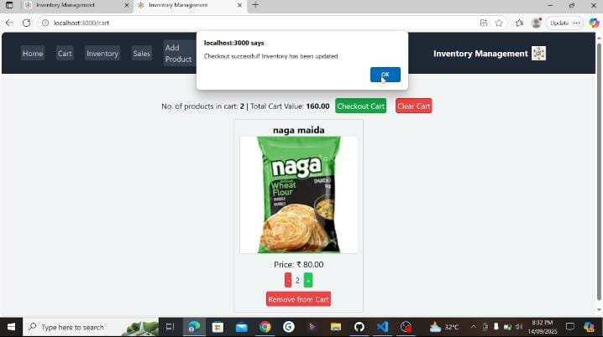

Inventory:

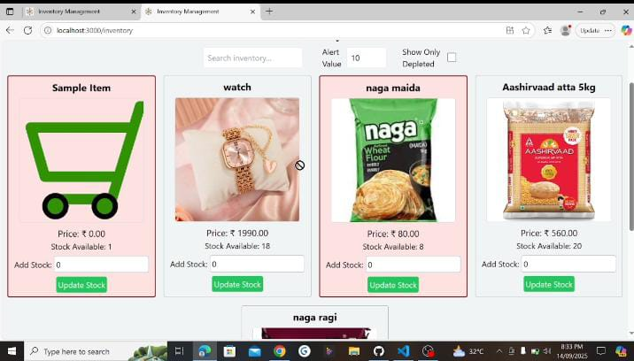

Sales records :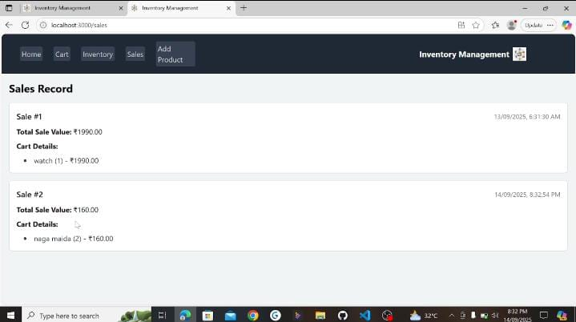

Add product :

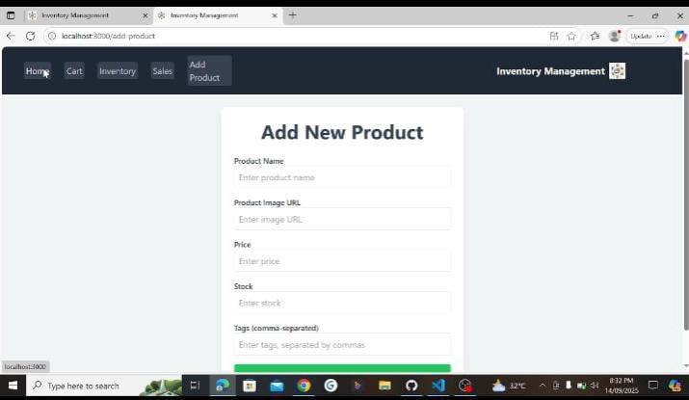

API Documentation

Add Product API → Adds a new product.

Update Stock API → Updates stock when items are sold.

Get Products API → Displays product catalog.

Sales History API → Shows past transactions.

(Currently simulated with React state, can be extended to real backend in future.)

Authentication

Present project works without authentication.

Future upgrade:

Admin (Manager): Full access.

Cashier/User: Limited access.

Can be implemented using JWT or Firebase Authentication.

User Interface (UI)

Built with React and CSS.

Simple and responsive design.

Navigation bar for quick access to Home, Add Product, Cart, Sales History.

Easy-to-use forms and buttons for smooth interaction.

Testing

Unit Testing: Verified individual components.

Integration Testing: Ensured features work together correctly.

Functional Testing: Checked main workflows (Add Product → Cart → Checkout → Sales

History).

User Acceptance Testing: Tested in <http://localhost:3000> to ensure usability

Demo link:

<https://drive.google.com/file/d/1IX2ezYZmRrwPybg7zVN8xdj48dFjtDXy/view?usp=drivesdk>

Future Enhancements:

Connect to a real backend and database (Node.js + MySQL/MongoDB).

Implement user authentication with roles (Admin, Cashier).

Generate automated reports and analytics.

Deploy as a cloud-based web application for real-time usage.

Conclusions:

The Store Manager project successfully demonstrates how a small retail store can

digitalize its inventory and sales process. It reduces manual errors, improves accuracy,

and makes product management and billing faster and more efficient.

This project proves that even a simple system built using React.js can handle real-world

store operations like adding products, managing stock, checkout, and sales history.

Overall, the project meets its objectives of being user-friendly, efficient, and reliable, and it

lays a strong foundation for future improvements like authentication, database

integration, and deployment.